Sr. No. | Name | Designation | Department | Qualification | Joining Date | Photo
 | Dr.Smitha | Medical Superintendent | Hospital Staff | MD | 29-03-2023 | 
 | Dr.Mamta Sarda | Deputy  Medical Superintendent | Hospital Staff | BAMS,MBA | 01-02-2022 | 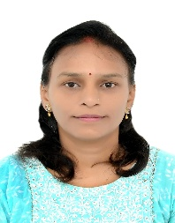
 | Dr.Sapna Thakur | Consultant/ Kayachikitsa | Hospital Staff | MD | 01-02-2023 | 
 | Dr. Sakshi Tyagi | Consultant/ Agadtantra | Hospital Staff | MD | 13-02-2023 | 
 | Dr.PoonaNath Chouhan | Consultant/ Shalya Tantra | Hospital Staff | MS | 19-11-2021 | 
 | Dr.Sneha Panzade | Consultant/ Kaumarbhrtiya | Hospital Staff | MD | 17-Oct-24 | 
 | Dr Sreejith K | Consultant/Agad Tantra | Hospital Staff | MD | 24-06-2024 | 
 | Dr.Harshalben Patel | Consultant/ Panchkarma | Hospital Staff | MD | 01-12-2022 | 
 | Dr.Dhanraj Nagar | Consultant/ Swasthvritta | Hospital Staff | MD | 09-Oct-24 | 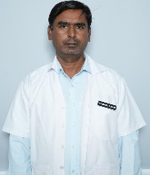
 | Dr. Athira | Consultant/ Swasthvritta | Hospital Staff | MD | 26-05-2025 | 
 | Dr. Yesha Soni | Consultant/ PTSR | Hospital Staff | MD | 17-10-2024 | 
 | Dr.DurgaLal Sharma | Consultant/Agad Tantra | Hospital Staff | MD | 03-Oct-24 | 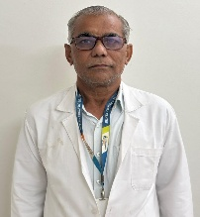
 | Dr. Manoj C John | Consultant/Shalya Tantra | Hospital Staff | M.S. | 03-03-2026 | 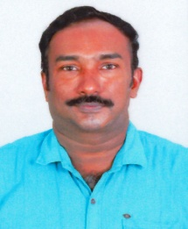
 | Dr.Jay Alkesh kumar Patel | Consultant/ Panchkarma | Hospital Staff | M.D. | 13-3-2026 | 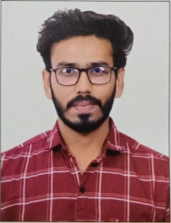
 | Dr. Ganesh Dan | Consultant/Shalkya Tantra | Hospital Staff | M.S. | 20-02-2026 | 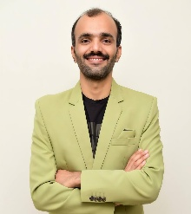
 | Dr. Jittesh Bhatt | Consultant/Shalkya Tantra | Hospital Staff | M.S. | 13-3-2026 | 
 | Dr. Mukesh Brahmbhatt | Consultant/ Kaumarbhrtiya | Hospital Staff | M.D. | 13-3-2026 | 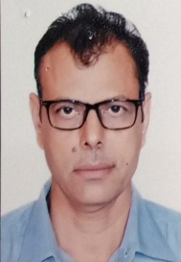
 | Dr.Vrushti Patel | Consultant/ PTSR | Hospital Staff | M.S. | 13-3-2026 | 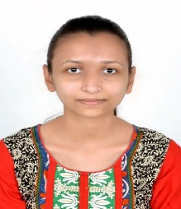
 | Dr.Vishant  Kumar Prajapati | Resident medical officer or surgical or medical officer | Hospital Staff | BAMS | 04-10-2022 | 
 | Dr. Dhara Modi | Resident medical officer or surgical or medical officer | Hospital Staff | BAMS | 01-11-2022 | 
 | Dr.Vishva Prajapati | Resident medical officer or surgical or medical officer  or clinical registar | Hospital Staff | BAMS | 20-012025 | 
 | Dr. Modh Hinal | Resident medical officer or surgical or medical officer  or clinical registar | Hospital Staff | BAMS | 17-02-2025 | 
 | Dr. Anjli Patel | Resident medical officer or surgical or medical officer | Hospital Staff | BAMS | 2-12-2025 | 
 | Dr. Diya Patel | Resident medical officer or surgical or medical officer | Hospital Staff | BAMS | 4-2-2026 | 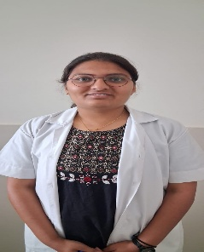
 | Dr.Rahil Khan Pathan | Resident medical officer or surgical or medical officer | Hospital Staff | BAMS | 11-02-2026 | 
 | Dr.Manan Patel | Resident medical officer or surgical or medical officer | Hospital Staff | BAMS | 1-11-2025 | 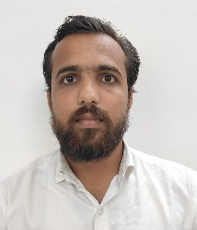
 | Dr. Abhik Raval | Resident medical officer or surgical or medical officer | Hospital Staff | BAMS | 1-11-2025 | 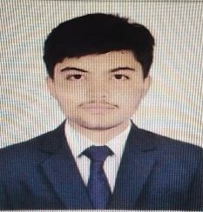
 | Dr. Urvi Patel | Resident medical officer or surgical or medical officer | Hospital Staff | BAMS | 1-11-2025 | 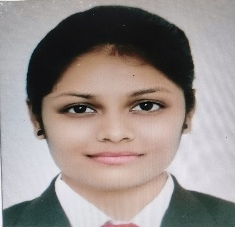
 | Dr.Khusi Ramchandani | Resident medical officer or surgical or medical officer | Hospital Staff | BAMS | 9-12-2025 | 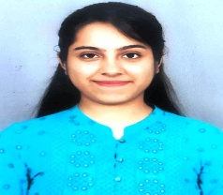
 | Dr.Kavita Chaudhari | Resident medical officer or surgical or medical officer | Hospital Staff | BAMS | 21-11-2025 | 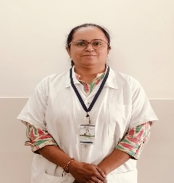
 | Dr.Minal Pandya | Resident medical officer or surgical or medical officer | Hospital Staff | BAMS | 1-8-2025 | 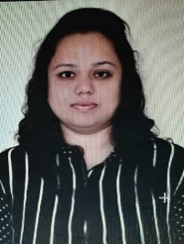
 | Dr. Margi Patel | Resident medical officer or surgical or medical officer | Hospital Staff | BAMS | 06-03-2026 | 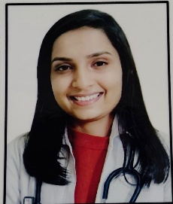
 | Dr. Barot Aditya  Manish kumar | Physiotherapist | Hospital Staff | BPT | 03-03-2026 | 